System and Software Architecture Description (SSAD)

JEP On-line Platform

Team 15

Wei Yan -System Architect

Shreya Nigam -Project Manager

Rebecca Lin -Feasibility Analyst

Reem Alfayez -Requirements Engineer

Wei-Ting Cheng -Life Cycle Planner

Nicholas Pecoraro -IIV&V

Image26.png

USC-CSSE

Wei Yan

Table of Contents

System Context Diagram

Artifacts and Information Diagram

Actors Grid

Use Cases Grid

Process Diagram

Hardware Component Class Diagram

Software Component Class Diagram

Deployment Diagram

User Interface Class Diagram

Login and Role Management Class Diagram

Check-in Class Diagram

Document Management Class Diagram

Message Management Class Diagram

Volunteer Class Diagram

Site Management Diagram

Login Sequence Diagram

Checkin Sequence Diagram

Table of Figures

System Context Diagram

Artifacts and Information Diagram

Process Diagram

Hardware Component Class Diagram

Software Component Class Diagram

Deployment Diagram

User Interface Class Diagram

Login and Role Management Class Diagram

Check-in Class Diagram

Document Management Class Diagram

Message Management Class Diagram

Volunteer Class Diagram

Site Management Diagram

Login Sequence Diagram

Checkin Sequence Diagram

# System Context Diagram

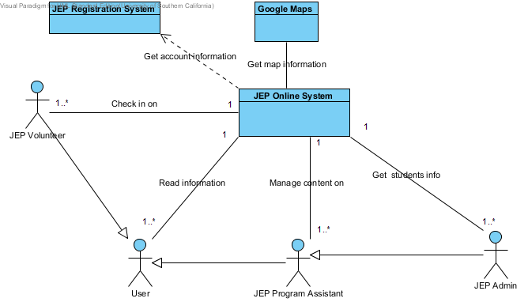

## Details

### Image1.png Google Maps

### Image1.png JEP Registration System

### Image2.png 1..*

### Image3.png User

### Image3.png JEP Admin

### Image3.png JEP Program Assistant

### Image3.png JEP Volunteer

### Image1.png JEP Online System

# Artifacts and Information Diagram

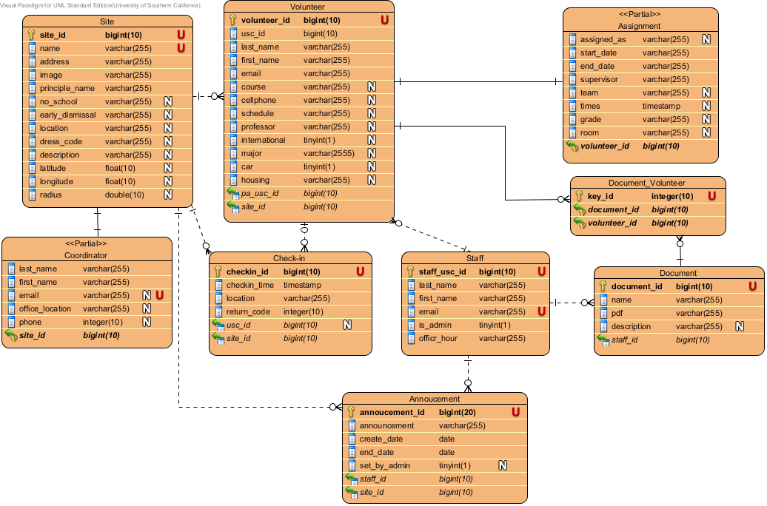

## Details

### Image5.png Volunteer

### Image5.png Assignment

### Image5.png Site

### Image5.png Document_Volunteer

### Image5.png Coordinator

### Image5.png Check-in

### Image5.png Staff

### Image5.png Document

### Image5.png Annoucement

# Actors Grid

|  |  |  |
| --- | --- | --- |
| **ID** | **Name** | **Related Use Cases** |
| AC01 | JEP Program Assistant | Export check-in Add Announcement Edit Announcement Manage JEP documents Browse volunteer information |
| AC02 | JEP Volunteer | View JEP documents View my sites information View schedule information Get directions Check in |
| AC03 | JEP Admin | Delete Site Edit Site Search volunteer information Delete User Edit User Add Site Add User |
| AC04 | User | Logout Login |

# Use Cases Grid

|  |  |  |  |
| --- | --- | --- | --- |
| **ID** | **Name** | **Primary Actors** | **Supporting Actors** |
| UC01 | Check in | JEP Volunteer |  |
| UC02 | View my sites information | JEP Volunteer |  |
| UC03 | Get directions | JEP Volunteer |  |
| UC04 | View JEP documents | JEP Volunteer |  |
| UC05 | View schedule information | JEP Volunteer |  |
| UC06 | Export check-in | JEP Program Assistant |  |
| UC07 | Browse volunteer information | JEP Program Assistant |  |
| UC08 | Manage JEP documents | JEP Program Assistant |  |
| UC09 | Add Announcement | JEP Program Assistant |  |
| UC10 | Edit Announcement | JEP Program Assistant |  |
| UC11 | Login | User |  |
| UC12 | Logout | User |  |
| UC13 | Search volunteer information | JEP Admin |  |
| UC14 | Add User | JEP Admin |  |
| UC15 | Edit User | JEP Admin |  |
| UC16 | Delete User | JEP Admin |  |
| UC17 | Add Site | JEP Admin |  |
| UC18 | Edit Site | JEP Admin |  |
| UC19 | Delete Site | JEP Admin |  |

# Process Diagram

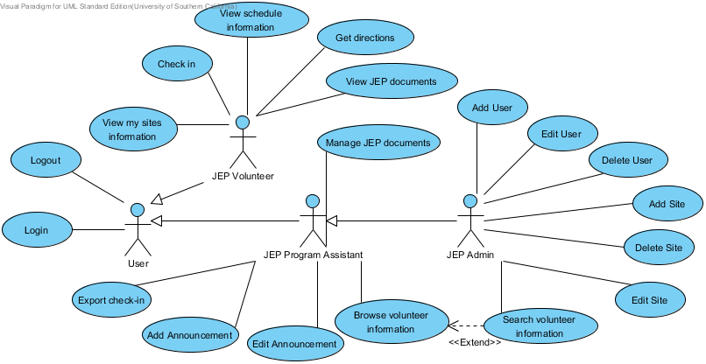

## Details

### Image3.png User

### Image3.png JEP Volunteer

### Image3.png JEP Program Assistant

### Image3.png JEP Admin

### Image7.png Edit Announcement

#### Use Case Descriptions

|  |  |
| --- | --- |
| **Main** | |
| **Identifier** | UC10: Edit Announcement |
| **Purpose** | To edit the existed announcement from the platform |
| **Requirements** | WC_2833: As a JEP staff(PA,Admin), I can edit the message that students will get when they checked_in by setting the message start date, end date, and content. |
| **Development Risks** | None |
| **Preconditions** | The user has logged in as PA or Admin. |
| **Post-conditions** | The announcement has been updated successfully, or the announcement is deleted. |
| **Typical Course of Action** | |  |  |  | | --- | --- | --- | |  | **Actor Input** | **System Response** | | 1 | Click "Manage Announcement" link |  | | 2 |  | Display a page with the message list which contains current messages | | 3 | Select an existed Announcement and click "Edit" button |  | | 4 |  | Display a page with the saved announcement information. | | 5 | Revise the information for the announcement |  | | 6 | Click "Save" button |  | | 7 |  | Save the revised announcement into the database | | 8 |  | Display a window showing success | |
| **Alternative Course of Action (Delete Announcement)** | |  |  |  | | --- | --- | --- | |  | **Actor Input** | **System Response** | | 1 | Click "Manage Announcement" link |  | | 2 |  | Display a page with the announcement list which contains current messages | | 3 | Select an existed announcement and click "Delete" button |  | | 4 |  | Delete the announcement entry from database | | 5 |  | Display a window showing success | |

### Image7.png Delete User

#### Use Case Descriptions

|  |  |
| --- | --- |
| **Main** | |
| **Identifier** | UC16: Delete User |
| **Purpose** | To delete an existed user's role from JEP system |
| **Requirements** | WC_2832: As an admin, I can delete users' (admin, and PA) roles in the system. |
| **Development Risks** | None |
| **Preconditions** | The user has logged into the system as JEP admin. |
| **Post-conditions** | The selected user's role has been successfully removed from the JEP system. |
| **Typical Course of Action** | |  |  |  | | --- | --- | --- | |  | **Actor Input** | **System Response** | | 1 | Click "Manage User" |  | | 2 |  | Redirect to a page for user management with the current users (admin, and PA) list | | 3 | Select a user and click delete icon |  | | 4 |  | Display confirmation message | | 5 | Confirm deletion |  | | 6 |  | Remove the selected user's role from database | | 7 |  | Display success message | |

### Image7.png Edit Site

#### Use Case Descriptions

|  |  |
| --- | --- |
| **Main** | |
| **Identifier** | UC18: Edit Site |
| **Purpose** | To edit the current site information. |
| **Requirements** | WC_2824: As an admin, I can edit site information Name, Dress Code, No School, Early Dismissal, Image, Office Location, Office Location, Address, Principal Name, Coordinator's info (First Name, Last Name, e-mail, Office Location) |
| **Development Risks** | None |
| **Preconditions** | The user has logged into the system as JEP admin. |
| **Post-conditions** | The site information has been updated in the database. |
| **Typical Course of Action** | |  |  |  | | --- | --- | --- | |  | **Actor Input** | **System Response** | | 1 | Click "Sites" link |  | | 2 |  | Redirect to a page with the current sites list | | 3 | Choose a site and click edit |  | | 4 |  | Display a page with the specific site information form | | 5 | Edit the site information and click submit |  | | 6 |  | Update the site information in the database | | 7 |  | Display success message | |

### Image7.png Add Site

#### Use Case Descriptions

|  |  |
| --- | --- |
| **Main** | |
| **Identifier** | UC17: Add Site |
| **Purpose** | To add a new site into the JEP online system |
| **Requirements** | WC_2823: As an admin, I can add site information including Name,Dress Code,No School,Early Dismissal,Image,Office Location,Office Location,Address,Principal Name,Coordinator's info(First Name,Last Name ,e-mail,Office Location) |
| **Development Risks** | None |
| **Preconditions** | The user has logged into the system as JEP admin. |
| **Post-conditions** | The new site has been added into the database, or nothing has been changed. |
| **Typical Course of Action** | |  |  |  | | --- | --- | --- | |  | **Actor Input** | **System Response** | | 1 | Click "Sites" link |  | | 2 |  | Redirect to a page with the current sites list | | 3 | Click "Add" button |  | | 4 |  | Open a new window with site information form | | 5 | Enter site name, address, picture and notes, then click create |  | | 6 |  | Check existing situation for the new site | | 7 |  | Display success message | |
| **Exceptional Course of Action (The site information doesn't follow the format)** | |  |  |  | | --- | --- | --- | |  | **Actor Input** | **System Response** | | 1 | Click "site" link |  | | 2 |  | Redirect to a page with the current site list | | 3 | Click "add new site" button |  | | 4 |  | Open a new window with site information form | | 5 | Enter site name, address, picture and notes, then click create |  | | 6 |  | show the error column with reason | |

### Image7.png Delete Site

#### Use Case Descriptions

|  |  |
| --- | --- |
| **Main** | |
| **Identifier** | UC19: Delete Site |
| **Purpose** | To delete an existing site from the JEP online system. |
| **Requirements** | WC_2825: As an admin, I can delete a site. |
| **Development Risks** | May cause some students belongs to none site. |
| **Preconditions** | The user has logged into the system as JEP admin. |
| **Post-conditions** | The site has been deleted from database. |
| **Typical Course of Action** | |  |  |  | | --- | --- | --- | |  | **Actor Input** | **System Response** | | 1 | Click "site" link |  | | 2 |  | Redirect to a page with the site list | | 3 | Choose a site and click delete |  | | 4 |  | Remove the site item from database | | 5 |  | Display a success message | |

### Image7.png Add Announcement

#### Use Case Descriptions

|  |  |
| --- | --- |
| **Main** | |
| **Identifier** | UC09: Add Announcement |
| **Purpose** | To set announcement which students will get when they check in and login between the start date and finish date |
| **Requirements** | WC_2789: As a JEP staff(PA,Admin), I can add the message that volunteers will get when they checked_in |
| **Development Risks** | None |
| **Preconditions** | The user has logged in as PA or Admin. |
| **Post-conditions** | The announcement has been set successfully, or the announcement is invalid. |
| **Typical Course of Action** | |  |  |  | | --- | --- | --- | |  | **Actor Input** | **System Response** | | 1 | Click "Announcement" link |  | | 2 |  | Display a page with the announcement list which contains current announcements | | 3 | Click "Add New Announcement" |  | | 4 |  | Display a page with the sites list for the PA or admin (admin will see all the sites in the database) | | 5 | Select the sites and click "Add" |  | | 6 |  | Display a empty form for announcement | | 7 | Input the new announcement contend, its start date and finish date in the form |  | | 8 | Click "Submit" button |  | | 9 |  | Check time conflict situation | | 10 |  | Record the announcement into database | | 11 |  | Direct back to Announcement page | |
| **Exceptional Course of Action**  (Time Conflict) | |  |  |  | | --- | --- | --- | |  | **Actor Input** | **System Response** | | 1 | Input the new announcement contend, its start date and finish date in the form |  | | 2 | Click "Submit" button |  | | 3 |  | Check time conflict situation | | 4 |  | Display error alert about time conflict | |

### Image7.png Add User

#### Use Case Descriptions

|  |  |
| --- | --- |
| **Main** | |
| **Identifier** | UC14: Add User |
| **Purpose** | To add new users to the system and assign initial role |
| **Requirements** | WC_2819: As an admin, I can add users (admin, and PA) to the system by adding their USC ID, and selecting their role(Admin, PA) |
| **Development Risks** | None |
| **Preconditions** | The user has logged into the system as JEP admin. |
| **Post-conditions** | A new user has been added into the system with his role, or nothing has been changed |
| **Typical Course of Action** | |  |  |  | | --- | --- | --- | |  | **Actor Input** | **System Response** | | 1 | Click user "Manage User" link |  | | 2 |  | Redirect to a page for user management | | 3 | Click "Add User" button |  | | 4 |  | Display a form with text input area and drop-down list for roles | | 5 | Input new user's USC ID, First name, Last Name, Email, Office hours and select his role and click submit |  | | 6 |  | Check the USC ID existing or not | | 7 |  | Adding the new user into database | | 8 |  | Display success message | |
| **Exceptional Course of Action**  (User already exists) | |  |  |  | | --- | --- | --- | |  | **Actor Input** | **System Response** | | 1 | Click user "manage permission" link |  | | 2 |  | Redirect to a page for user management | | 3 | Click add new link |  | | 4 |  | Display a form with text input area and checkable radio button for roles | | 5 | Input new user's USC ID and select his role and click submit |  | | 6 |  | Check the USC ID existing or not | | 7 |  | Display already existing error | |
| Exceptional Course of Action (invalid email format) | |  |  |  | | --- | --- | --- | |  | **Actor Input** | **System Response** | | 1 | Enter invalid email format. |  | | 2 |  | Display invalid email format label. | |
| Exceptional Course of Action (missing USC ID) | |  |  |  | | --- | --- | --- | |  | **Actor Input** | **System Response** | | 1 | Click submit without entering USC ID |  | | 2 |  | Display a label USC ID cannot be empty. | |

### Image7.png Edit User

#### Use Case Descriptions

|  |  |
| --- | --- |
| **Main** | |
| **Identifier** | UC15: Edit User |
| **Purpose** | To edit the admin or PA's role for JEP online system |
| **Requirements** | WC_2820: As an admin, I can edit users' (admin, and PA) roles in the system. |
| **Development Risks** | None |
| **Preconditions** | The user has logged into the system as JEP admin. |
| **Post-conditions** | The specific user's role has been changed. |
| **Typical Course of Action** | |  |  |  | | --- | --- | --- | |  | **Actor Input** | **System Response** | | 1 | Click "Manager User" link |  | | 2 |  | Redirect to a page for user management with current users' list | | 3 | Select a user and click "edit" button |  | | 4 |  | Display a window with the users' information (USC ID, First name, Last name, role, email, office hours). | | 5 | Edit the values (First name,Last name, role, email, office hours) and click "Edit" button |  | | 6 |  | Update the user's information in our database | | 7 |  | Display success information | |
| Exceptional Course of Action (Email Wrong) | |  |  |  | | --- | --- | --- | |  | **Actor Input** | **System Response** | | 1 | Enter invalid email format. |  | | 2 |  | Display invalid email format label. | |

### Image7.png Browse volunteer information

#### Extension Points

|  |  |
| --- | --- |
| **ExtensionPoint** | |

#### Use Case Descriptions

|  |  |
| --- | --- |
| **Main** | |
| **Identifier** | UC07: Browse volunteer information |
| **Purpose** | To see the information about volunteers who are assigned to the PA. |
| **Requirements** | WC_2784: As JEP PA, I can browse my student information. |
| **Development Risks** | None |
| **Preconditions** | The user has logged into the system as Program Assistant. |
| **Post-conditions** | Get the information about the PA's volunteers, or no volunteer has been find. |
| **Typical Course of Action** | |  |  |  | | --- | --- | --- | |  | **Actor Input** | **System Response** | | 1 | Click "My Volunteers" link |  | | 2 |  | show the criteria options for the search | | 3 | enter the criteria and click "search" bottom |  | | 4 |  | show the table contain the volunteers base on the criteria | |
| **Exceptional Course of Action**  (No volunteer for the PA) | |  |  |  | | --- | --- | --- | |  | **Actor Input** | **System Response** | | 1 | Click "My Volunteers" link |  | | 2 |  | Show the criteria options for the search | | 3 | Enter the criteria and click "search" bottom |  | | 4 |  | show nothing in the table | |

### Image7.png Manage JEP documents

#### Use Case Descriptions

|  |  |
| --- | --- |
| **Main** | |
| **Identifier** | UC08: Manage JEP Documents |
| **Purpose** | To upload or delete JEP documents |
| **Requirements** | WC_2782: As a program assistant , I can upload JEP important documents |
| **Development Risks** | None |
| **Preconditions** | The user has logged into the system as JEP program assistant. |
| **Post-conditions** | The uploaded document has been recorded into or deleted from web server, or nothing has been changed. |
| **Typical Course of Action**  (Upload) | |  |  |  | | --- | --- | --- | |  | **Actor Input** | **System Response** | | 1 | Click "Documents" link |  | | 2 |  | Display a page that contains a form for uploading documents | | 3 | Click "Choose File" button |  | | 4 |  | Pop up a window for selecting the document | | 5 | Select the document and click "Open" |  | | 6 |  | Save the document path | | 7 | Input the file name and description |  | | 8 | Click "Submit" |  | | 9 |  | Check the format whether the document is PDF or .doc and the size is smaller than 10 MB | | 10 |  | Add the document into the server and information into the database. | | 11 |  | Display success submit message | | 12 |  | Open select students page | | 13 | Search for students and select students then click "Add" . |  | | 14 |  | Display success message | |
| **Alternative Course of Action**  (Delete) | |  |  |  | | --- | --- | --- | |  | **Actor Input** | **System Response** | | 1 | Select a document and click "Delete" icon |  | | 2 |  | Display a confirmation window | | 3 | Select "OK" |  | | 4 |  | Delete document from the server and database | | 5 |  | Display success deletion message | |
| **Alternative Course of Action** (Download) | |  |  |  | | --- | --- | --- | |  | **Actor Input** | **System Response** | | 1 | Select a document and click "Download" icon |  | | 2 |  | Download the documents into the local machine | |
| **Exceptional Course of Action**  (Failure: the document type is not allowed or its size is larger than limits) | |  |  |  | | --- | --- | --- | |  | **Actor Input** | **System Response** | | 1 | Click "Submit" |  | | 2 |  | Check the format whether the document is PDF or .doc and the size is smaller than 10 MB | | 3 |  | Pop up alert based on the error type. (Not PDF or .doc document or the size is larger than 10 MB) | |

### Image7.png Logout

#### Use Case Descriptions

|  |  |
| --- | --- |
| **Main** | |
| **Identifier** | UC12: Logout |
| **Purpose** | To log out a user who has logged in the JEP online system |
| **Requirements** | UC_2786: As a user, I can log out. |
| **Development Risks** | None |
| **Preconditions** | The user has logged into the system. |
| **Post-conditions** | The user successfully has logged out the platform, and see an specific page. |
| **Typical Course of Action** | |  |  |  | | --- | --- | --- | |  | **Actor Input** | **System Response** | | 1 | Click the Logout button |  | | 2 |  | Log the user out and deactivate the user's session | | 3 |  | Show a page that tells the user "To ensure log out, you must completely quit/close your web browser." | |

### Image7.png Login

#### Use Case Descriptions

|  |  |
| --- | --- |
| **Main** | |
| **Identifier** | UC11: Login |
| **Purpose** | Authorizing a user to log into the platform |
| **Requirements** | WC_2785: As a user I can log in.  WC_2787: As a user, I can view the proper website view based on my role after I logged in |
| **Development Risks** | Secure connection protocol may be required. |
| **Preconditions** | The database is connected and initialized. |
| **Post-conditions** | The user has successfully log into the platform and see the homepage, or redirect to Dornsife, or user still keep in the login page with error message. |
| **Typical Course of Action** | |  |  |  | | --- | --- | --- | |  | **Actor Input** | **System Response** | | 1 | Enter username and password in the login form |  | | 2 | Click "Log in" button |  | | 3 |  | Verify input username and password combination by Shibboleth | | 4 |  | Check the user's role in our database | | 5 |  | Redirect to a specific index page based on his current role | |
| **Alternative Course of Action**  (Forget Password) | |  |  |  | | --- | --- | --- | |  | **Actor Input** | **System Response** | | 1 | Click "Forget Password" button |  | | 2 |  | Link to Dornsife registration system "forget password" | |
| **Exceptional Course of Action** (Wrong username/password combination) | |  |  |  | | --- | --- | --- | |  | **Actor Input** | **System Response** | | 1 | Enter username and password in the login form |  | | 2 | Click "Log in" button |  | | 3 |  | Verify input username and password combination | | 4 |  | Display the failure login information in the login page | |

### Image7.png Export check-in

#### Use Case Descriptions

|  |  |
| --- | --- |
| **Main** | |
| **Identifier** | UC06: Export check-in |
| **Purpose** | View volunteers' attendance to help grading and comment to volunteers |
| **Requirements** | WC_2610: As a program assistant, I can export my students check-ins information which includes(date,time,and site). |
| **Development Risks** | None |
| **Preconditions** | The user has logged into the system as Program Assistant. The attendance records are ready. |
| **Post-conditions** | Program assistant can know the result of attendance for the selected volunteer. Or no available record is displayed. |
| **Typical Course of Action** | |  |  |  | | --- | --- | --- | |  | **Actor Input** | **System Response** | | 1 | Click on "view" link |  | | 2 |  | show the record of the student. | | 3 | Click on "export to excel" |  | | 4 |  | pop out the frame to ask user to choose directory and file name. | | 5 | select directory and file name and save. |  | |
| **Exceptional Course of Action**  (Fail to get record) | |  |  |  | | --- | --- | --- | |  | **Actor Input** | **System Response** | | 1 | Click on "view" button |  | | 2 |  | show nothing about the record | | 3 | Click "Export" |  | | 4 |  | have no action for the click | |

### Image7.png View JEP documents

#### Use Case Descriptions

|  |  |
| --- | --- |
| **Main** | |
| **Identifier** | UC04: View JEP Documents |
| **Purpose** | To see JEP documents |
| **Requirements** | WC_2781: As a JEP volunteer, I can view a list of all JEP documents. |
| **Development Risks** | None |
| **Preconditions** | The user has logged into the system as a volunteer. The list of JEP documents are ready. |
| **Post-conditions** | Display the content of the selected JEP document. Or no document can be find. |
| **Typical Course of Action** | |  |  |  | | --- | --- | --- | |  | **Actor Input** | **System Response** | | 1 | Click "My Documents" link |  | | 2 |  | Verify the existence of documents | | 3 |  | Redirect to a page with the list of documents | | 4 | Click the specific document name which the user wants to download |  | | 5 |  | Download the documents into the local machine | |

### Image7.png Search volunteer information

#### Use Case Descriptions

|  |  |
| --- | --- |
| **Main** | |
| **Identifier** | UC13: Search volunteer Information |
| **Purpose** | To search specific volunteers information from all JEP volunteers |
| **Requirements** | WC_2794: As JEP Admin, I can search student view and their information |
| **Development Risks** | None |
| **Preconditions** | The user has logged into the system as JEP admin. |
| **Post-conditions** | View the specific volunteer information, or no volunteer is found. |
| **Typical Course of Action** | |  |  |  | | --- | --- | --- | |  | **Actor Input** | **System Response** | | 1 | Click on " Volunteer Info" link |  | | 2 |  | show the criteria options for the search | | 3 | enter the criteria and click "search" |  | | 4 |  | show the table contain volunteer base on the criteria | | 5 | click "detail info" |  | | 6 |  | Display the specific volunteer's information | |
| **Exceptional Course of Action**  (The input name and ID are invalid) | |  |  |  | | --- | --- | --- | |  | **Actor Input** | **System Response** | | 1 | Click on " Volunteer Info" link |  | | 2 |  | show the criteria options for the search | | 3 | Enter the volunteer's name and ID |  | | 4 |  | show nothing in the table | |

### Image7.png Get directions

#### Use Case Descriptions

|  |  |
| --- | --- |
| **Main** | |
| **Identifier** | UC03: Get directions |
| **Purpose** | Get the directions from current location to site by various transportation methods. |
| **Requirements** | WC_2643: As a JEP volunteer, I can see maps to and from community sites and USC. |
| **Development Risks** | Some sites may not near street. |
| **Preconditions** | The user has logged into the system as Volunteer. The user is currently on the Check In page |
| **Post-conditions** | Show the navigation from current location or specific location to site. |
| **Typical Course of Action** | |  |  |  | | --- | --- | --- | |  | **Actor Input** | **System Response** | | 1 | Click "Direction" button for a specific site in the Check In page |  | | 2 |  | Display the map with directions from my current location to site with default "driving" mode | |
| **Alternative Course of Action**  (Change Mode of Transport) | |  |  |  | | --- | --- | --- | |  | **Actor Input** | **System Response** | | 1 | Click "Direction" button for a specific site in the Check In page |  | | 2 |  | Display a map with a selection form for transportation | | 3 | Select a transport mode |  | | 4 |  | Display the map with directions from my specific location to site by using selected transport method | |

### Image7.png View schedule information

#### Use Case Descriptions

|  |  |
| --- | --- |
| **Main** | |
| **Identifier** | UC05: View schedule information |
| **Purpose** | Display schedule to user |
| **Requirements** | WC_2645: As a JEP volunteer, I can log in and find my site information including location, description, and site times that I am supposed to go there. |
| **Development Risks** | None |
| **Preconditions** | The user has logged into the system as a volunteer. |
| **Post-conditions** | Display the schedule or non-existence alert to user |
| **Typical Course of Action** | |  |  |  | | --- | --- | --- | |  | **Actor Input** | **System Response** | | 1 | Click "My Schedule" link |  | | 2 |  | Check the existence of schedule | | 3 |  | Display MySchedule Page with schedule information | |
| **Exceptional Course of Action**  (Fail to get schedule) | |  |  |  | | --- | --- | --- | |  | **Actor Input** | **System Response** | | 1 | Click "My Schedule" link |  | | 2 |  | Check the existence of schedule | | 3 |  | Display MySchedule Page with non-existence alert | |

### Image7.png View my sites information

#### Use Case Descriptions

|  |  |
| --- | --- |
| **Main** | |
| **Identifier** | UC02: View my site information |
| **Purpose** | To know the information about the assigned community site |
| **Requirements** | WC_2645: As a JEP volunteer, I can log in and find my site information including location, description, and site times that I am supposed to go there. |
| **Development Risks** | None |
| **Preconditions** | The user has logged into the system as a volunteer. The JEP admin has created the site information. |
| **Post-conditions** | Get the information about my specific site. Or nothing has been displayed. |
| **Typical Course of Action** | |  |  |  | | --- | --- | --- | |  | **Actor Input** | **System Response** | | 1 | Click "Check In" tab in the main page |  | | 2 |  | Check whether the students has been assigned to at least one site. | | 3 |  | Display the assigned sites list | | 4 | Click "View" icon for a specific site |  | | 5 |  | Display this site's information on a new page | |
| **Exceptional Course of Action**  (No Site information) | |  |  |  | | --- | --- | --- | |  | **Actor Input** | **System Response** | | 1 | Click "Check In" tab in the main page |  | | 2 |  | Check whether the students has been assigned to at least one site. | | 3 |  | Pop up alert: no site information | |

### Image7.png Check in

#### Use Case Descriptions

|  |  |
| --- | --- |
| **Main** | |
| **Identifier** | UC01: Check in |
| **Purpose** | Allow volunteers check in at specific sites |
| **Requirements** | WC_2609: As a JEP volunteer, I can check-in my geo location on through the website either from my phone or pc, to confirm my attendance at a school or volunteer site.  WC_2651: As a JEP volunteer, I get a message when I check in |
| **Development Risks** | May produce high traffic load to Google Maps API |
| **Preconditions** | The user has logged into the system as a volunteer. |
| **Post-conditions** | The check-in record would be saved in database and display success message, or display alert message. |
| **Typical Course of Action** | |  |  |  | | --- | --- | --- | |  | **Actor Input** | **System Response** | | 1 | Click "Check In" tab in the main page |  | | 2 |  | Open a new page with the site lists and Check In button | | 3 | Click a specific site's Check In button |  | | 4 |  | Compare the current location with the site location | | 5 |  | Pop-up success check-in announcement based on the comparison result | |
| **Exceptional Course of Action**  (Failure: out of site range) | |  |  |  | | --- | --- | --- | |  | **Actor Input** | **System Response** | | 1 | Click "Check In" tab in the main page |  | | 2 |  | Open a new page with the site lists and Check In button | | 3 | Click a specific site's Check In button |  | | 4 |  | Compare the current location with the site location | | 5 |  | Pop-up alert : Check In fail | |

# Hardware Component Class Diagram

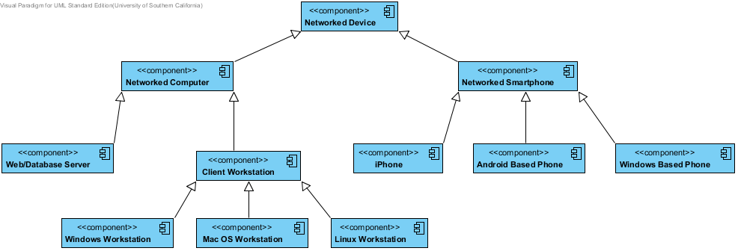

## Details

### Image9.png Networked Device

### Image9.png Networked Computer

### Image9.png Networked Smartphone

### Image9.png Web/Database Server

### Image9.png iPhone

### Image9.png Android Based Phone

### Image9.png Windows Based Phone

### Image9.png Client Workstation

### Image9.png Windows Workstation

### Image9.png Mac OS Workstation

### Image9.png Linux Workstation

# Software Component Class Diagram

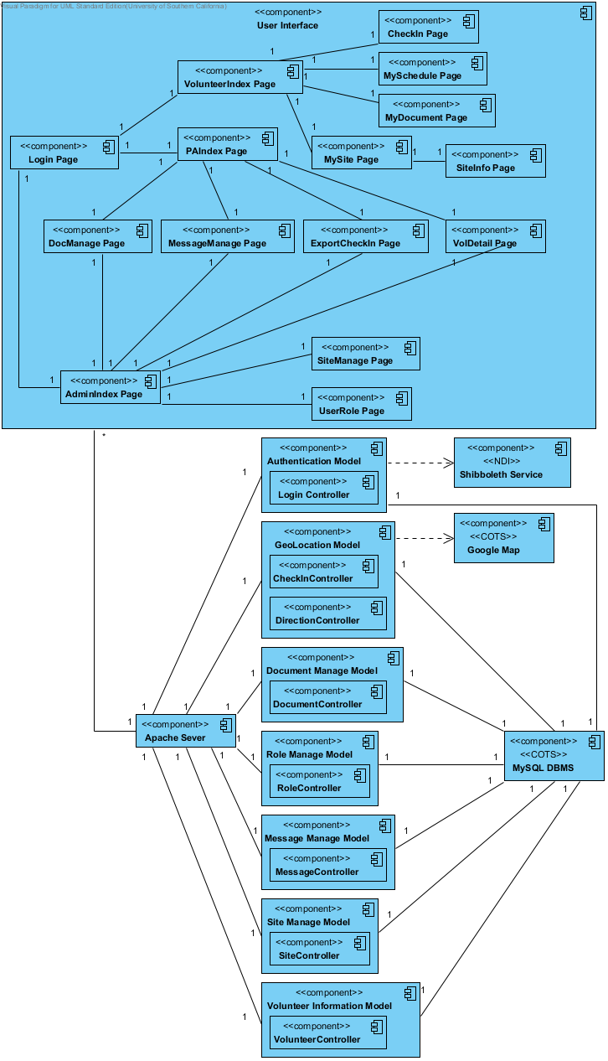

## Details

### Image9.png User Interface

### Image9.png CheckIn Page

### Image9.png MySchedule Page

### Image9.png VolunteerIndex Page

### Image9.png MyDocument Page

### Image9.png PAIndex Page

### Image9.png Login Page

### Image9.png MySite Page

### Image9.png SiteInfo Page

### Image9.png DocManage Page

### Image9.png MessageManage Page

### Image9.png ExportCheckIn Page

### Image9.png VolDetail Page

### Image9.png SiteManage Page

### Image9.png AdminIndex Page

### Image9.png UserRole Page

### Image9.png Authentication Model

### Image9.png Shibboleth Service

### Image9.png Login Controller

### Image9.png Google Map

### Image9.png GeoLocation Model

### Image9.png CheckInController

### Image9.png DirectionController

### Image9.png Document Manage Model

### Image9.png DocumentController

### Image9.png Apache Sever

### Image9.png Role Manage Model

### Image9.png MySQL DBMS

### Image9.png RoleController

### Image9.png Message Manage Model

### Image9.png MessageController

### Image9.png Site Manage Model

### Image9.png SiteController

### Image9.png Volunteer Information Model

### Image9.png VolunteerController

# Deployment Diagram

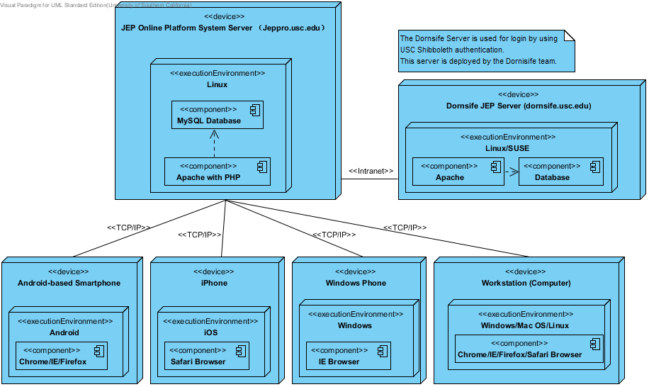

## Details

### Image12.png JEP Online Platform System Server （Jeppro.usc.edu）

### Image12.png Linux

### Image12.png Dornsife JEP Server (dornsife.usc.edu)

### Image9.png MySQL Database

### Image12.png Linux/SUSE

### Image9.png Apache with PHP

### Image9.png Apache

### Image9.png Database

### Image12.png Android-based Smartphone

### Image12.png iPhone

### Image12.png Windows Phone

### Image12.png Workstation (Computer)

### Image12.png Windows

### Image12.png Windows/Mac OS/Linux

### Image12.png Android

### Image12.png iOS

### Image9.png Chrome/IE/Firefox/Safari Browser

### Image9.png Safari Browser

### Image9.png IE Browser

### Image13.png N/A

# User Interface Class Diagram

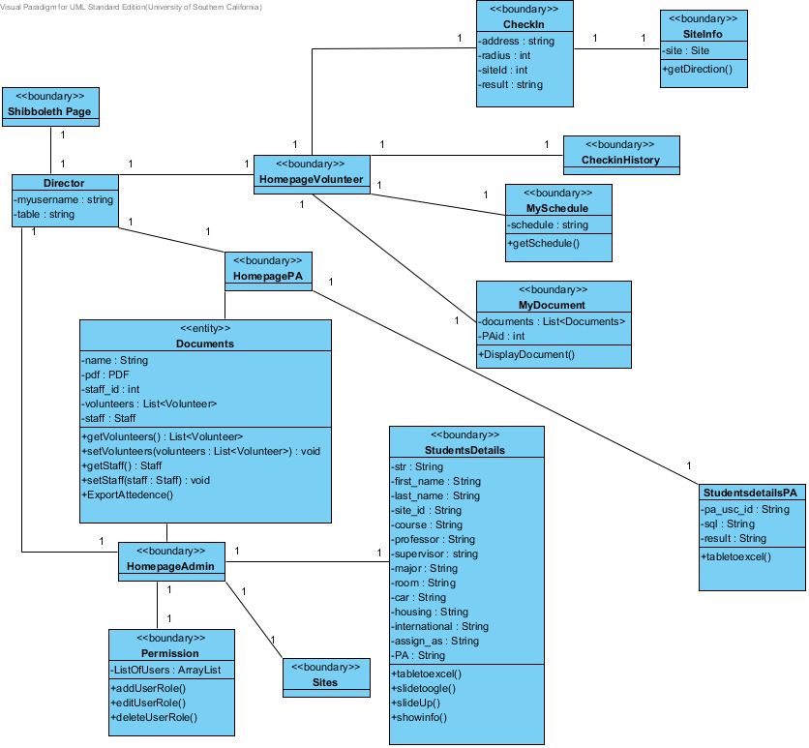

## Details

### Image1.png CheckIn

### Image1.png SiteInfo

### Image1.png Shibboleth Page

### Image1.png CheckinHistory

### Image1.png HomepageVolunteer

### Image1.png Director

### Image1.png MySchedule

### Image1.png HomepagePA

### Image1.png MyDocument

### Image1.png Documents

### Image1.png StudentsDetails

### Image1.png StudentsdetailsPA

### Image1.png HomepageAdmin

### Image1.png Permission

### Image1.png Sites

# Login and Role Management Class Diagram

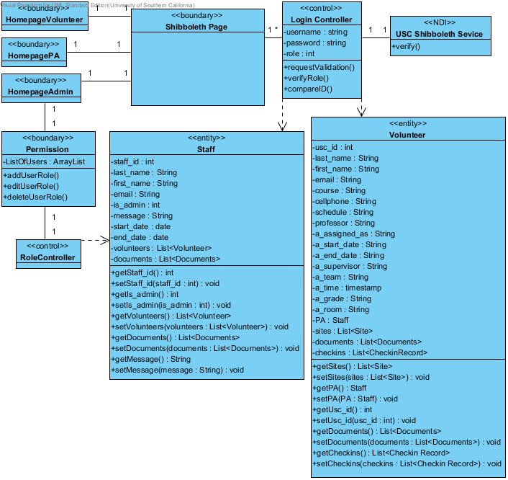

## Details

### Image1.png HomepageVolunteer

### Image1.png Login Controller

### Image1.png Shibboleth Page

### Image1.png USC Shibboleth Sevice

### Image1.png HomepagePA

### Image1.png HomepageAdmin

### Image1.png Volunteer

### Image1.png Permission

### Image1.png Staff

### Image1.png RoleController

# Check-in Class Diagram

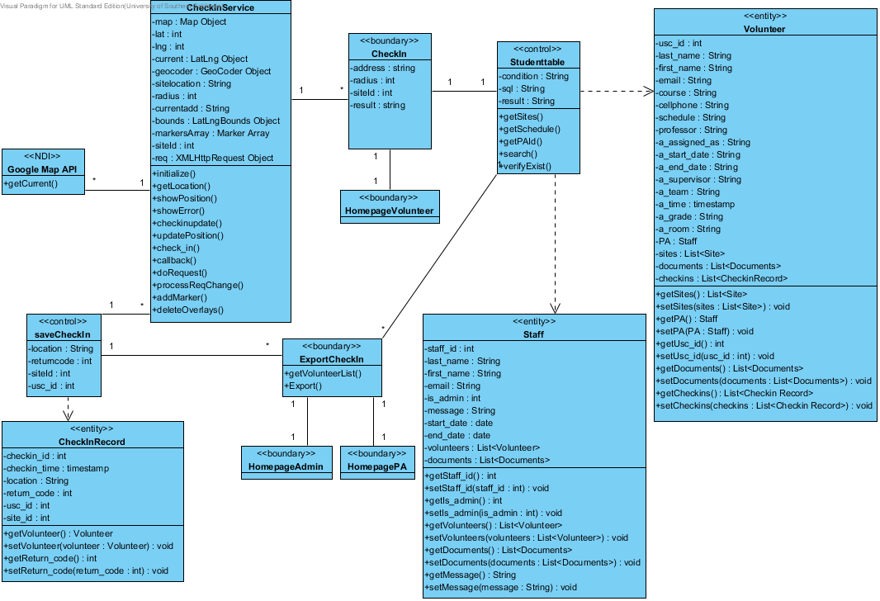

## Details

### Image1.png CheckInService

### Image1.png Volunteer

### Image1.png CheckIn

### Image1.png Studenttable

### Image1.png Google Map API

### Image1.png HomepageVolunteer

### Image1.png saveCheckIn

### Image1.png Staff

### Image1.png ExportCheckIn

### Image1.png CheckInRecord

### Image1.png HomepageAdmin

### Image1.png HomepagePA

# Document Management Class Diagram

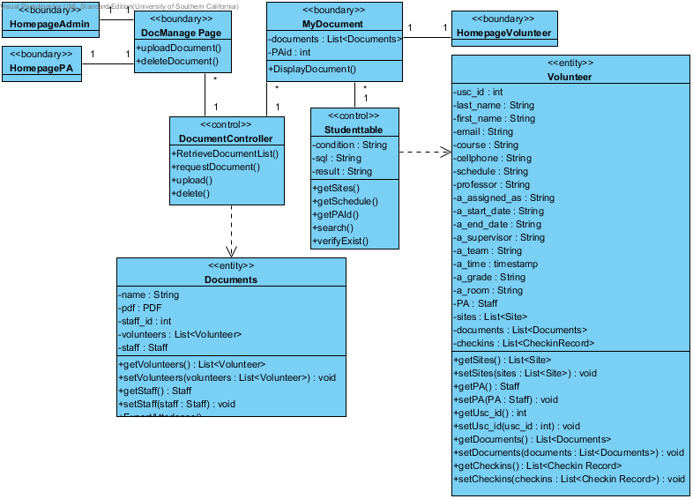

## Details

### Image1.png HomepageAdmin

### Image1.png MyDocument

### Image1.png DocManage Page

### Image1.png HomepageVolunteer

### Image1.png HomepagePA

### Image1.png Volunteer

### Image1.png Studenttable

### Image1.png DocumentController

### Image1.png Documents

# Message Management Class Diagram

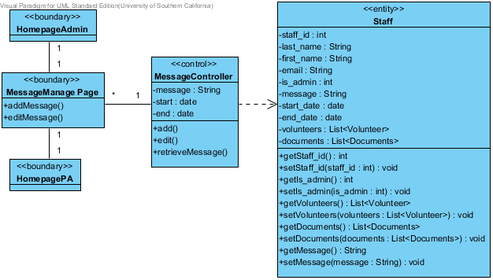

## Details

### Image1.png Staff

### Image1.png HomepageAdmin

### Image1.png MessageController

### Image1.png MessageManage Page

### Image1.png HomepagePA

# Volunteer Class Diagram

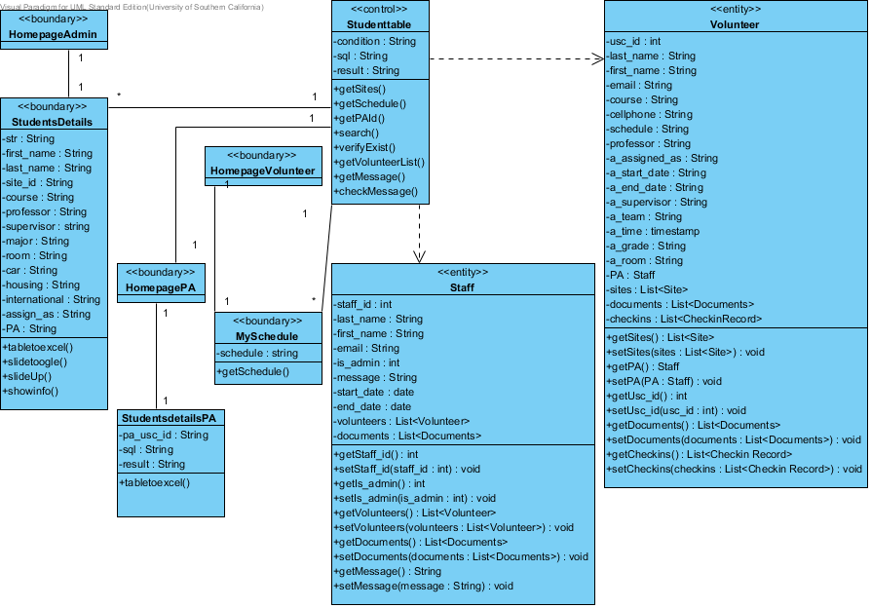

## Details

### Image1.png Studenttable

### Image1.png Volunteer

### Image1.png HomepageAdmin

### Image1.png StudentsDetails

### Image1.png HomepageVolunteer

### Image1.png HomepagePA

### Image1.png Staff

### Image1.png MySchedule

### Image1.png StudentsdetailsPA

# Site Management Diagram

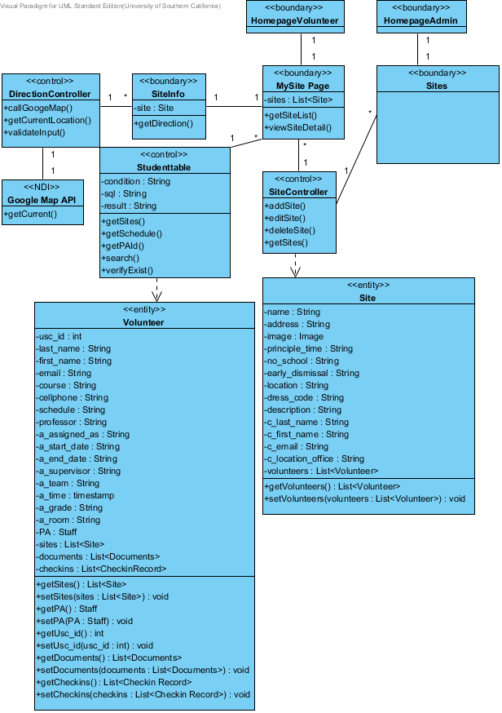

## Details

### Image1.png HomepageVolunteer

### Image1.png HomepageAdmin

### Image1.png MySite Page

### Image1.png Sites

### Image1.png DirectionController

### Image1.png SiteInfo

### Image1.png Studenttable

### Image1.png SiteController

### Image1.png Google Map API

### Image1.png Site

### Image1.png Volunteer

# Login Sequence Diagram

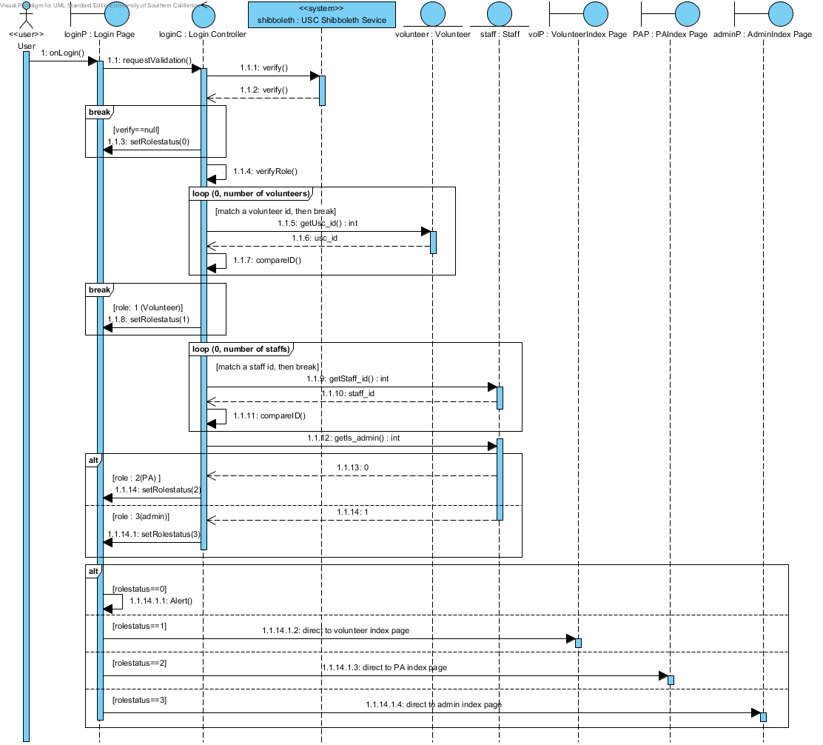

## Details

### Image3.png User

### Image22.png loginP : Login Page

### Image22.png loginC : Login Controller

### Image22.png shibboleth : USC Shibboleth Sevice

### Image22.png volunteer : Volunteer

### Image22.png staff : Staff

### Image22.png volP : VolunteerIndex Page

### Image22.png PAP : PAIndex Page

### Image22.png adminP : AdminIndex Page

### Image23.png Verify

### Image23.png roleVolunteer

### Image23.png findPA

### Image23.png findAdmin

### Image23.png showAlert

### Image23.png showVolP

### Image23.png compareStaff

### Image23.png showPAP

### Image23.png showAdminP

### Image24.png CombinedFragment8

### Image24.png CombinedFragment7

### Image24.png CombinedFragment6

### Image24.png CombinedFragment5

### Image23.png compareVolunteer

### Image24.png CombinedFragment4

### Image24.png CombinedFragment3

# Checkin Sequence Diagram

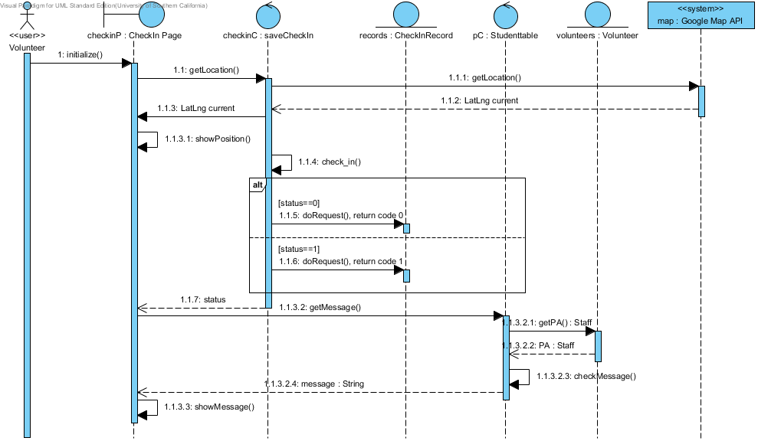

## Details

### Image3.png Volunteer

### Image22.png checkinP : CheckIn Page

### Image22.png checkinC : saveCheckIn

### Image22.png map : Google Map API

### Image22.png records : CheckInRecord

### Image22.png pC : Studenttable

### Image22.png volunteers : Volunteer

### Image23.png chickinfail

### Image23.png checkinsuccess

### Image24.png CombinedFragment